**SOFTWARE**

**REQUIREMENTS**

**SPECIFICATION**

**FOR**

**RECIPE MANAGWEMENT SYSTEM**

**PREPARED BY:-**

**AMIRTHAVARSHNI C R**

**GOBIKA Y**

**HARINIE M**

**1.Introduction**

**1.1 Purpose**

The main objective of this document is to illustrate the requirements of the project Recipe Management System (RMS). The RMS is a digital platform designed to streamline the process of storing ,managing and sharing culinary recipes. The document gives the detailed description of both functional and non-functional requirements proposed by the users. The main purpose of this project is to provide a friendly environment to maintain the details of recipe. Individuals can store their favourite recipes, discover new ones and collaborate with others in a culinary community. Whether a home cook, professional chef or culinary enthusiast RMS aims to enhance the cooking experience by offering an organized repository of diverse recipes. A digital assistant to help you organize and discover all your favorite recipes effortlessly. Our recipe management system is designed to make cooking a delightful experience! You can easily store and categorize your recipes based on various criteria such as cuisine, dietary preferences, or even occasions. You'll have a centralized hub where you can access your recipes anytime. It offers smart features like meal planning and grocery list generation, ensuring that you never miss an ingredient for your favorite dish. You can even customize your meal plans based on your dietary restrictions or nutritional goals.

**1.2Documentation Conventions**

* Entire document should be justified.
* Convention for Main title
* Font face: Times New Roman
* Font Style: Bold
* Font Size: 28
* Convention for Sub title
* Font face: Times New Roman
* Font Style: Bold
* Font size:18
* Convention for Body
* Font face: Times New Roman
* Font size:12

**1.3Scope of Development Project**

Recipe Management System is a software platform that helps you create, organize, and share recipes for your recipes. It can help you save time, reduce costs, improve quality, and increase consistency in your cooking. Some of the features of a cooking recipe management system are:

* You can create and edit recipes using a user-friendly interface.
* You can search and filter through your recipes by ingredients, categories, or keywords.
* You can share your recipes with your team members or customers via email or social media.
* You can track the inventory of ingredients and equipment needed for each recipe.
* You can plan your menus based on the availability of ingredients and customer preferences.
* You can analyze the costs and profits of each recipe and menu.

There are many benefits of using a cooking recipe management system for your recipes. Some of them are:

* You can save time by creating new dishes and menus faster and easier.
* You can reduce costs by avoiding waste and overstocking of ingredients.
* You can improve quality by ensuring that all recipes are prepared correctly and consistently.
* You can increase customer satisfaction by offering them a variety of dishes that suit their tastes and dietary needs.

The blog of the first user cannot be modified by the second user.

**1.4Definition,Acronyms and Abbrevations**

JAVA->platform independence

SQL->Structured Query Language

ER->Entity Relationship

UML->Unified Modeling Language

IDE->Integrated Develpoment Environment

SRS->Software Requirement Specification

**1.5Reference**

**Books:**

* Software Requirements and Specifications: A Lexicon of Practice, Principles and Prejudices (ACM Press) by Michael Jackson
* Software Requirements (Microsoft) Second EditionBy Karl E. Wiegers
* Software Engineering: A Practitioner’s Approach Fifth Edition By Roger S. Pressman

**Website:**

[**https://www.coursehero.com/file/87100090/Spring-2020-CS619-4098-SRSdoc/**](https://www.coursehero.com/file/87100090/Spring-2020-CS619-4098-SRSdoc/)

**https://ieeexplore.ieee.org/abstract/document/6847024/references**

2. Overall Descriptions

**2.1 Product Perspective**

**2.2 Product Function**

Entity relationship Diagram of Recipe management System

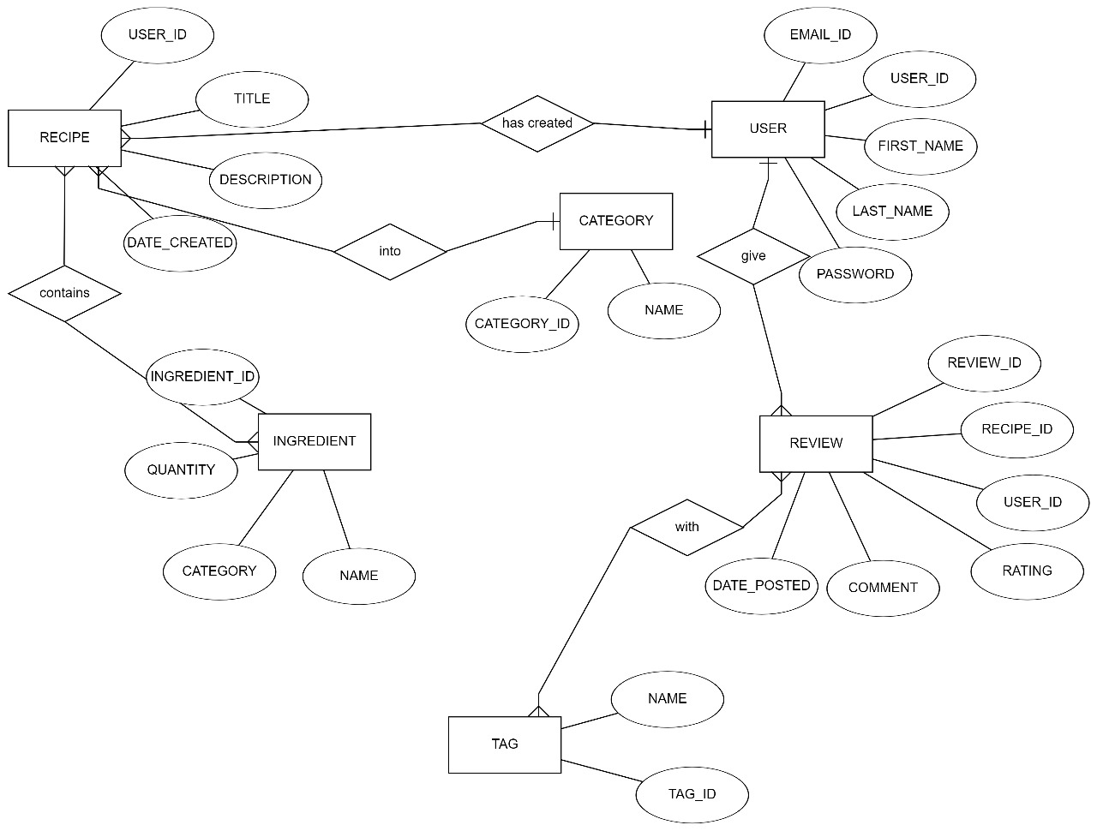

The entity relationships in the Recipe Management System are structured to capture key interactions and associations between users, recipes, ingredients, tags, categories, reviews, and cooking events. Users can create multiple recipes, each identified by a unique RecipeID, fostering a one-to-many relationship. Ingredients, Tags, and Categories form many-to-many relationships with recipes through dedicated junction tables, allowing flexibility in associating multiple elements. User-Review and User-CookingEvent relationships establish one-to-many connections, enabling users to contribute reviews and participate in various cooking events, enhancing user engagement and interaction within the system.

**2.3USE CASE DIAGRAM DESCRIPTION**

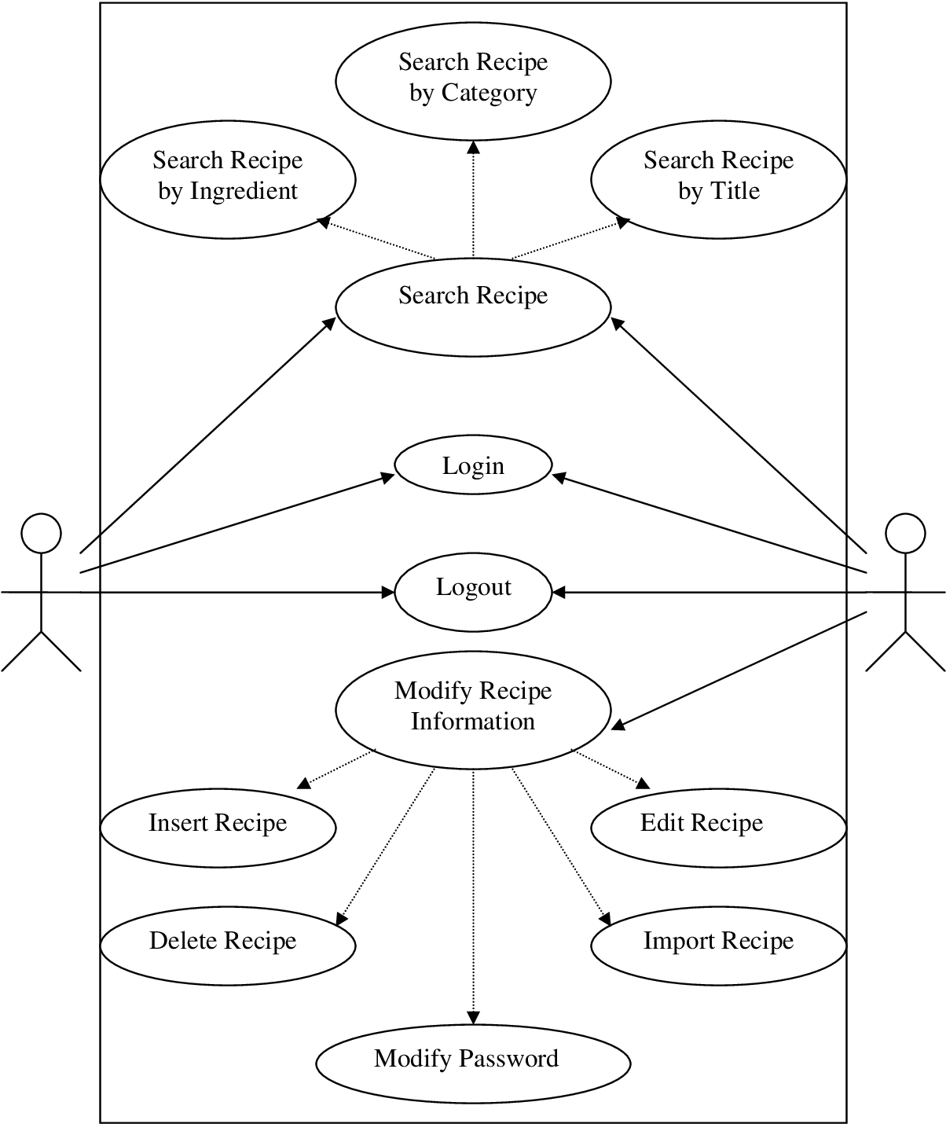

The Use Case Diagram for the Recipe Management System outlines pivotal interactions. Users can create recipes, search for specific recipes, select favorites, and view their account details. Additionally, they can submit reviews for recipes, contributing ratings and comments. Users are enabled to participate in cooking events, enhancing community engagement. The diagram encapsulates a user-centric approach, providing a visual representation of essential functionalities. It serves as a valuable tool for system understanding, ensuring efficient navigation and effective utilization of features within the Recipe Management System.

**2.4 Operating Environment**

The product will be operating in windows environment. The Recipe Management System is website/webapp and shall operate in all famous browsers, for a model we are taking Microsoft Internet Explorer,Google Chrome,and Mozilla Firefox.Also it will be compatible with the IE 6.0. Most of the features will be compatible with the Mozilla Firefox & Opera 7.0 or higher version. The only requirement to use this online product would be the internet connection. The hardware configuration include Hard Disk: 40 GB, Monitor: 15” Color monitor, Keyboard: 122 keys. The basic input devices required are keyboard, mouse and output devices are monitor, printer etc.

* 1. **Assumptions and Dependencies**

The assumptions are:-

* The coding should be error free
* The system should be user-friendly so that it is easy to use for users
* The information of all users, recipes and cooking methods should be stored in database that is accessible by the website/webapp
* The system should have more storage capacity and provide fast access to the databases
* The system should provide search facility and support quick transactions
* The Recipe Management System is running 24 hours a day
* Users may access from any computer that has Internet browsing capabilities and an Internet connection

**The dependencies are:-**

* The specific hardware and software due to which the product will be run
* On the basis of listing requirements and specification the project will be developed and run
* The end users (admin) should have proper understanding of the product
* The system should have the general report stored
* Any update regarding the recipe from the recorded to the database and the data entered should be correct

**2.6Requirement**

Software Configuration:

Front End Development:

Language: Java

Framework: Java Runtime Environment (JRE)

Integrated Development Environment (IDE): NetBeans 7.0.1

Back End Database:

Database Management System: Microsoft SQL Server

Support: Developed using Java supported by Sun Microsystems

Operating System:

Compatibility: Windows NT, Windows 98, Windows XP

Hardware Configuration:

Processor:

Type: Pentium(R) Dual-core CPU

Storage:

Hard Disk: 40GB

Memory (RAM):

Capacity: 256 MB or more

Note:

The Recipe Management System is designed to operate on Windows NT, Windows 98, and Windows XP operating systems.

The software is developed using Java as the front end, supported by Sun Microsystems, with NetBeans 7.0.1 as the integrated development environment.

Microsoft SQL Server is utilized as the back-end database management system to store the recipe data.

The hardware configuration includes a Pentium(R) Dual-core CPU, a 40GB hard disk, and a minimum of 256 MB of RAM.

**2.7Data Requirements**

User Registration:

Input Types:

Username (Text)

Email (Text)

Password (Encrypted Text )

Recipe Query:

Input Types:

Query Text (Text)

User ID (Numeric)

Timestamp (DateTime)

Recipe Selection:

Input Types:

User ID (Numeric)

Recipe ID (Numeric)

Timestamp (DateTime)

User Account Details Request:

Input Types:

User ID (Numeric)

Timestamp (DateTime)

Rating Query:

Input Types:

User ID (Numeric)

Recipe ID (Numeric)

Timestamp (DateTime)

Rating Submission:

Input Types:

Recipe ID (Numeric)

User ID (Numeric)

Value (Numeric, Rating)

Timestamp (DateTime)

**3.External Interface Requirement**

**GUI**

The software provides good graphical interface for the user and administrator can operate on the system ,performing the required task such as create , update, viewing the details of the recipes , ratings and feedback about the recipes

* It allows user to view quick reports like recipes created/updated in a particular time.
* The user interface should be able to interact with the user management module and a part of the interface must be dedicated to the login/logout module.
* The user interface must be customized by administrator.
* Modules provide with the software must fit into this graphical user interface and accomplish to the standard defined.
* The design should be simple and all the different interfaces should follow a standard defined.

Login Interface:-

In case the user is not yet registered, he can enter details and register to create his account. Once his account is created he can ‘Login’ which asks the user to type his username and password. If the user entered either his username or password incorrectly then an error message appears.

Search:-

The user can type of recipe he is looking for and the title he is interested in, then he can search for the required recipe by entering the recipe name.

Categories View:-

Categories should shows the how many category would it contains and it provides users toad/edit or delete category from the list.

User’s Control Panel:-

This control panel will allow user to add/delete users; add, edit or remove a resource , and managing leading options.

**4. System Features**

The users of the system should be provided the surely that their account is secure. This is possible by providing the followings:-

* Creating
* Managing Recipes
* Tracking Inventory and Generating
* Generating production reports
* Ability to modify food and beverages recipes
* Storage of recipes
* Ability to launch tasks and processes accordingly
* Collection of information on the particular ingredients , formula, operations , advisories , equipment involved in creating a product
* Software that manages the complex relationships and processes related to production recipe

**5. Other Non-functional Requirements**

Administrator

Features:

Add Recipe:

Description: Administrators can add new recipes to the system, including details such as title, ingredients, instructions, etc.

Edit Recipe:

Description: Administrators have the privilege to edit the information of existing recipes in the system.

Delete Recipe:

Description: Administrators can remove recipes from the system, ensuring data accuracy.

View All Recipes:

Description: Administrators can view a comprehensive list of all recipes available in the system.

View Recipe Details:

Description: Administrators can access detailed information about a specific recipe, including ingredients, instructions, and authorship.

Manage Ingredients:

Description: Administrators can add, edit, or delete ingredients from the system's ingredient database.

Manage Categories:

Description: Administrators can add, edit, or delete recipe categories to organize recipes effectively.

Generate Reports:

Description: Administrators can generate reports on various aspects, such as popular recipes, ingredient usage, and user engagement.

User Management:

Description: Administrators have the authority to manage user accounts, including adding new users, modifying user details, and deactivating accounts.

viewer Features:

View All Recipes:

Description: Members can view a list of all available recipes in the system.

Search for Recipe:

Description: Members can search for a specific recipe based on title, category, or ingredients.

View Recipe Details:

Description: Members can access detailed information about a specific recipe, including ingredients, instructions, and authorship.

Save Favorite Recipes:

Description: Members can save their favorite recipes for quick access in the future.

Submit Reviews and Ratings:

Description: Members can provide feedback by submitting reviews and ratings for recipes they have tried.

Create Shopping Lists:

Description: Members can create and manage shopping lists based on the ingredients required for selected recipes.

Request New Recipes:

Description: Members can submit requests for specific recipes they would like to see added to the system.

View Personal Recipe History:

Description: Members can view their history of previously viewed recipes and recipes they have tried.

**6.User Categories for Recipe Management System:**

Administrator:

Access Rights: Full control (modify, delete, append).

Data Access: All functionalities enabled.

Chef:

Access Rights: Read-only (retrieve information).

Data Access: Viewing recipes, no modifications allowed.

Guest User :

Access Rights: Read-only (retrieve information).

Data Access: Viewing recipes, no modifications allowed.

Food Enthusiast :

Access Rights: Read-only (retrieve information).

Data Access: Viewing recipes, no modifications allowed.

Categories of Recipes and Relevant Data:

Cuisine Type:

Data Fields:

Recipes based on specific cuisines (Italian, Mexican, Indian, etc.)

Ingredients, instructions, cooking time, difficulty level, images, servings.

Meal Type:

Data Fields:

Categorization into breakfast, lunch, dinner, appetizers, desserts, etc.

Ingredients, instructions, cooking time, difficulty level, images, servings.

Dietary Preferences:

Data Fields:

Recipes catering to dietary preferences (vegetarian, vegan, gluten-free, etc.)

Ingredients, instructions, cooking time, difficulty level, images, servings, calorie information.

Occasions:

Data Fields:

Recipes suitable for occasions or events (holiday recipes, party dishes, etc.)

Ingredients, instructions, cooking time, difficulty level, images, servings.

Trending Recipes:

Data Fields:

Popular or trending recipes in the system.

Ingredients, instructions, cooking time, difficulty level, images, servings, user ratings.

These adjusted categories and user roles reflect the specific access rights and functionalities tailored for a Recipe Management System, ensuring that different types of users have appropriate permissions within the system while categorizing recipes based on various criteria for easy access and retrieval.

**6.1Appendix**

Appendix : A: Admin C: Class D: Data Requirements G: GUI M: Member N: Non-functional Requirements O: Operating Environment P: Purpose R: Requirement S: Security U: User

**6.2Glossary**

Conventions

Administrator: A user with administrative privileges within the Recipe Management System, capable of modifying, deleting, and managing user accounts and data.

User: General login ID assigned to users accessing the Recipe Management System.

Guest User: Limited access login assigned to users without editing privileges, used for viewing recipes and system content.

Recipe Category: Specific classifications (Cuisine Type, Meal Type, Dietary Preferences, Occasions, Trending Recipes) used for organizing recipes.

GUI (Graphical User Interface): The visual interface enabling users to interact with the Recipe Management System.

User Profile: Individual account containing user-specific details, preferences, and settings within the system.

Database: Storage repository housing recipes, user data, and system information.

System Features: Functionalities offered by the Recipe Management System to facilitate user interaction and recipe management.

Acronyms

GUI: Graphical User Interface

SQL: Structured Query Language

SQL Server: A server used to store data in an organized format

Use Case: A broad-level diagram showing the functionality and interactions within the Recipe Management System.

Class Diagram: A static structure diagram describing the structure of the system, including classes, their attributes, and relationships.

Interface: The medium used to communicate between different sections or modules of the Recipe Management System.

Unique Key: An attribute or set of attributes that uniquely identifies each record in a database table.

**6.3 CLASS DIAGRAM**

The class diagram illustrates key entities and their relationships in the Recipe Management System. Classes include User, Recipe, Ingredient, Tag, Category, Review, and Cooking Event, each encapsulating relevant attributes. Associations depict relationships such as User-Recipe (One-to-Many), Recipe-Ingredient (Many-to-Many), and Recipe-Category (Many-to-One). This diagram provides a concise visual representation of the system's structure, facilitating a comprehensive understanding of entity relationships and interactions.

